Visual Paradigm tutorial

1. Download Visual Paradigm Community Edition

* Go to: <http://www.visual-paradigm.com/download/vpuml.jsp?edition=ce>
* Select version to download: Windows 64bit (No Install) – If you are using Mac OS, click on Other operation systems, then MAC OS X (No Install)
* Locate the ZIP file in the download folder.
  + Windows:
    - Visual_Paradigm_for_UML_CE_Windows_64bit_NoInstall_10_2_20130617.zip
    - Unzip the file
  + MAC OS:
    - Visual_Paradigm_for_UML_CE_MacOSX_NoInstall_10_2_20130618.tar
    - Right click on the file- Select Open With\Archive Utility
* A new folder will be created.

1. Run Visual Paradigm

* Open the folder you just unzip:
  + Locate sub-folder named bin. Double click on file named Visual Paradigm for UML
* Click “No thanks, just start VP-UML…” button located at the bottom right of the window.
* Click Start
* Click ok to agree with the default workspace location

1. Open a project

* Click File\Open Project
* The project is located in SAFTINet Dropbox folder at \Technical Documents\Rosita UML\Rosita.vpp

1. The project content

* Use the Diagram navigator pane on the left hand side to explore the diagrams in this project.
* There are currently 10 activity diagrams and 1 deployment diagram
* Open the main diagram: Rosita Job
* Action with the fork symbol (Picture 1) at the bottom right corner has a sub diagram.

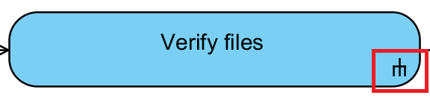

Picture - Fork symbol

* To open the sub activity diagram, click on the activity, the click on the sub-diagram symbol (very small) at the bottom right corner (Picture 2). Then, select the sub-diagram.

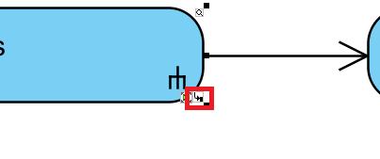

Picture - Sub-diagram symbol

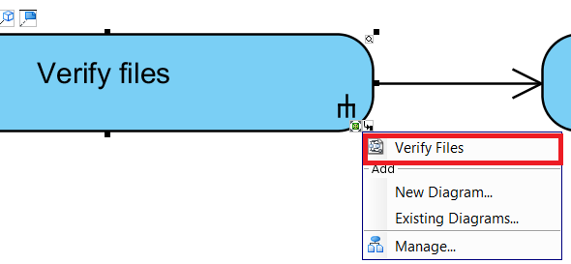

Picture - Select sub-diagram